**A Report**



**“PF Project**

**“Hospital Management System”**

**Representors**

**Muhammad Uneeb Khan (243729)**

**Muhammad Hamza Khan (243774)**

**Mir Haider Ali Gurchani (243776)**

**Under the Guidance of**

**Saad Ur Rehman**

**Department of Computer Science Air University Multan**

**TABLE OF CONTENT:**

Contents

1) INTRODUCTION: 3

2) Main Features/Functionalities: 3

Patient Management: 3

Doctor Management: 4

3) User: 7

4) Functionalities of Each Users: 7

5) Member-wise Project Task Breakdown: 8

Mir Haider Ali Gurchani: 8

He develops the following Things in the code: 8

• Made the command user interface to interact the user with the program. 8

• Display Menus at the beginning of the program. 8

• Made Signup and login system to provide protection to user data. 8

• Make hidden password input system to secure password more securely. 8

Muhammad Hamza Khan: He develops the following things in the code: 8

• He made 2nd menu after the first menu which was Add Patient and Add Doctor. 8

• He functionalized it properly and also use file handling. 8

• The menu input data from the user and then write it to the file. 8

• File handling is used to save all data in the file for later use. 8

Muhammad Uneeb Khan: 8

He develops the following things in the code: 8

• He made third and the last menu in the program. 8

• The menu provided 4 functions such as View Patients Records, View Doctor Records, Delete Patients Records, Delete Doctor Records. 8

• In this code, He used 4 functions and declared prototype at the beginning before main function. 8

• The functions are non-return type. 8

Hospital Management System

# INTRODUCTION:

The Hospital Management System is a software application designed to do hospital operations like manage patient and doctor records, and ensure efficient data handling. It allows users to perform critical tasks such as registering patients and doctors.

It also allows user to view Patients records, Doctor records and delete saved data securely. The system includes user authentication to protect sensitive information.

# Main Features/Functionalities:

* **User Authentication**: Secure Signup and Login system using stored credentials.

If User name and password Correct:

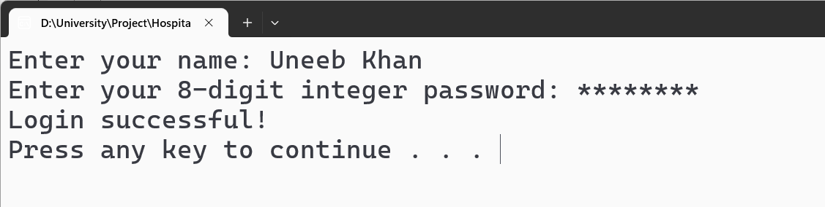

If Username or password is incorrect:

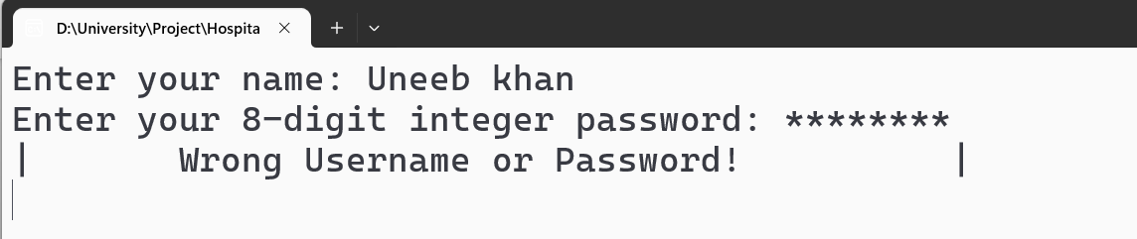

## Patient Management:

* Add new patient records.
* It includes Patient name, Blood Group, Patient disease. It add all the data on the file and then save them for later use.

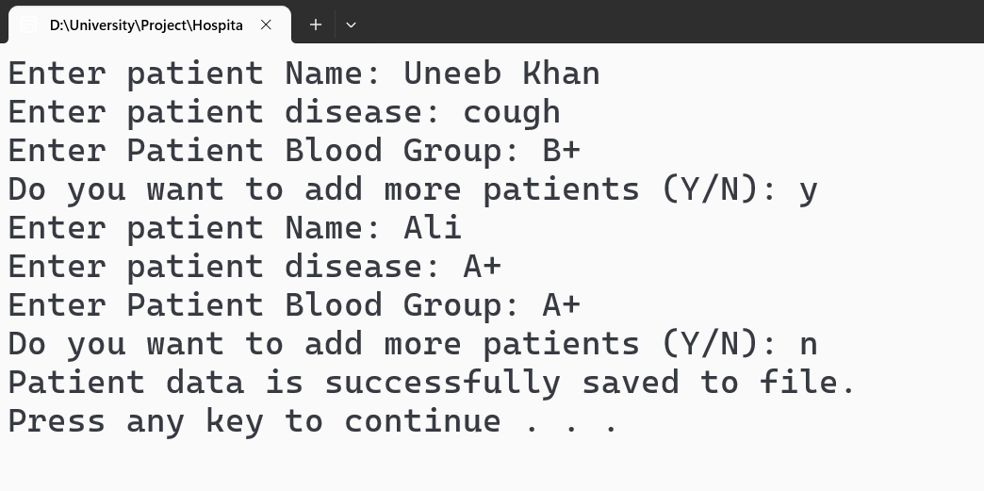

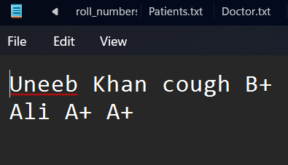

* There is a Functions in this code which is used to View or delete saved records.
* Delete specific patient records.

## Doctor Management:

* Add new doctor records.

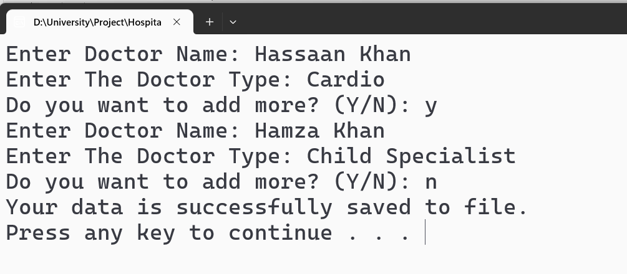

* **I used Function to View records of patient.**

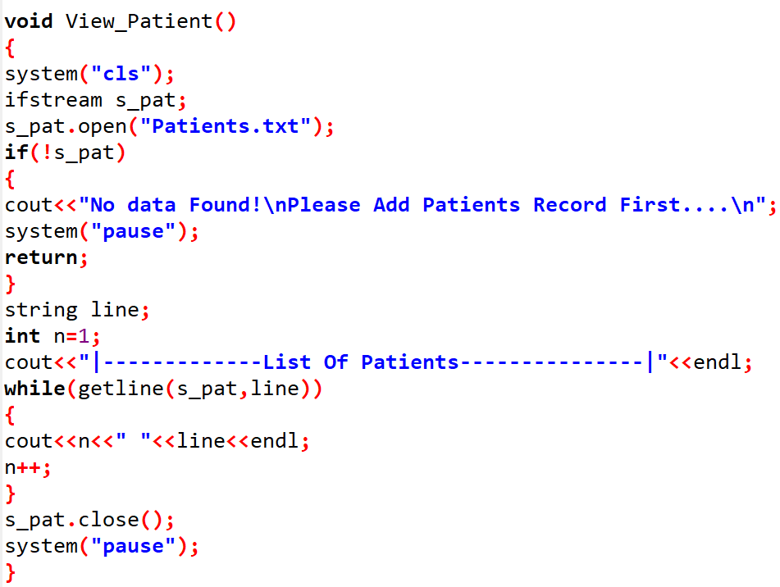

* **I used Function to view records of patient.**

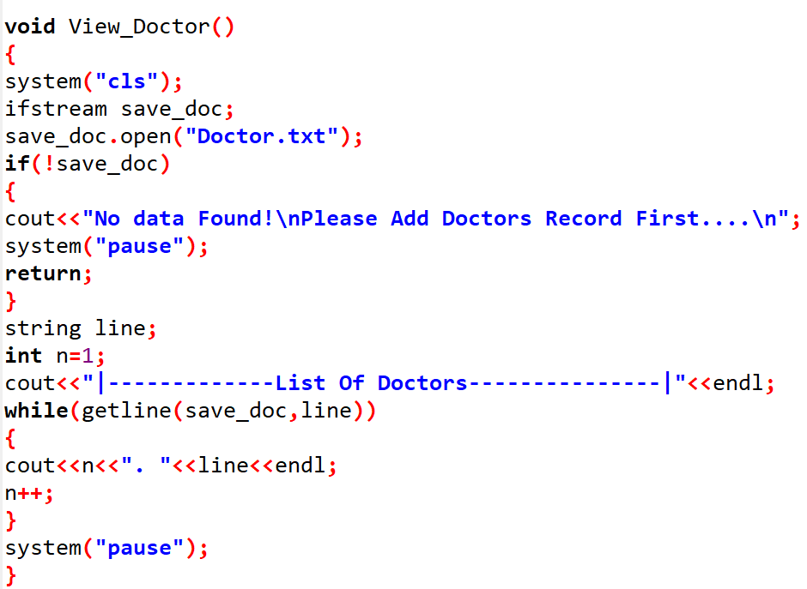

* **Delete doctor records function:**

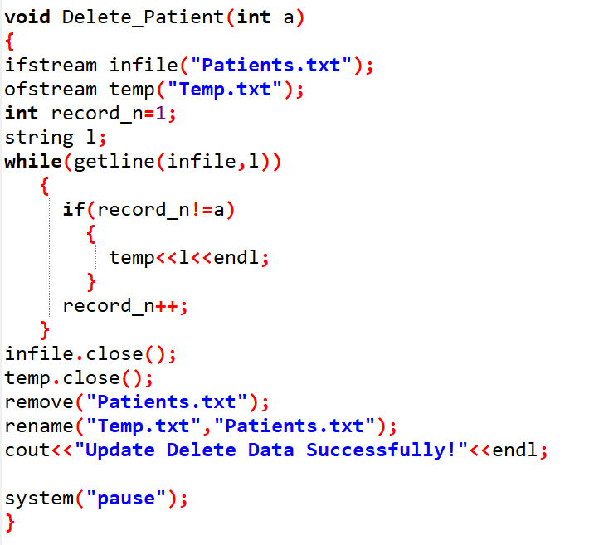

* **Delete doctor records function:**

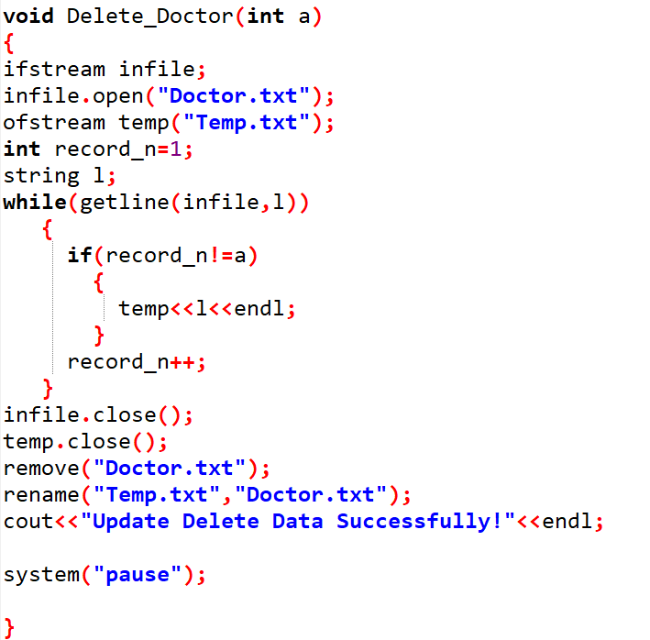

**File-Based Data Storage:**

All data is stored in files (Patients.txt, Doctor.txt) for persistent storage.

**Error Handling:**

Ensures smooth operation even when files are missing or no records are present.

For Example, in Login, If not any signup is made before then it will give error message on the console like:

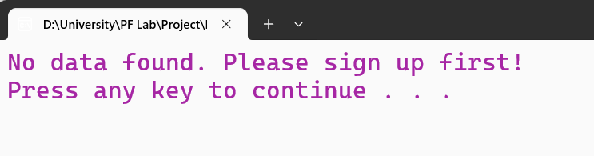

Error Display code:

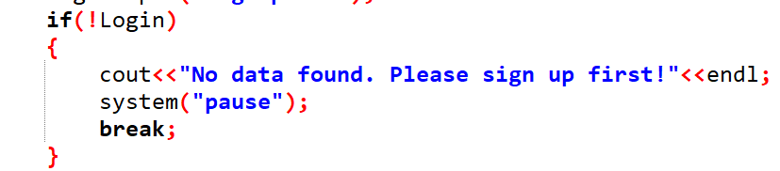

# User:

* Responsible for managing the hospital database.
* First User Signup to make account, the user must make an account if not any.
* Then user Login in the account. The username and password must match to the signup account to access menus.
* Authorized to add, view, and delete records for patients and doctors.

# Functionalities of Each Users:

* **Signup**: Create a new account by providing a username and password.
* **Login**: Authenticate using the saved credentials.
* **Add Patients**: Input patient details such as name, disease, and blood group.
* **Add Doctors**: Input doctor details such as name and specialization.
* **View Records**: View a list of all patients or doctors stored in the system.
* **Delete Records**: Remove patient or doctor records by specifying the record number.

# Member-wise Project Task Breakdown:

Mir Haider Ali Gurchani:

He develops the following Things in the code:

* Made the command user interface to interact the user with the program.
* Display Menus at the beginning of the program.
* Made Signup and login system to provide protection to user data.
* Make hidden password input system to secure password more securely.

Muhammad Hamza Khan:He develops the following things in the code:

* He made 2nd menu after the first menu which was Add Patient and Add Doctor.
* He functionalized it properly and also use file handling.
* The menu input data from the user and then write it to the file.
* File handling is used to save all data in the file for later use.

Muhammad Uneeb Khan:

He develops the following things in the code:

* He made third and the last menu in the program.
* The menu provided 4 functions such as View Patients Records, View Doctor Records, Delete Patients Records, Delete Doctor Records.
* In this code, He used 4 functions and declared prototype at the beginning before main function.
* The functions are non-return type.